Online Diary 2/11/2020

Joshua Baker

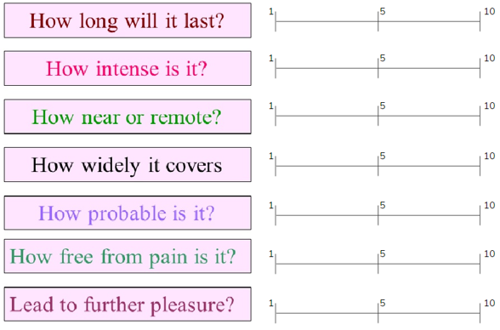This week I was joined by Zakaria Ahmed and Ben Miller. We were given the task to create a questionnaire to evaluate and playtest a game of our choice. We decided to playtest agar.io for its ease of access. For the questionnaire we were heavily inspired by Jeremy Bentham’s Felicific Calculus which was designed to calculate the amount of pleasure that a specific action is likely to cause. The felicific calculus could, in principle at least, determine the moral status of any considered act.

We used sliders for each question as its seen as one way for honest responses. Feedback was given on this which was to remove the mid-point in the sliders which is something we could look towards for improvement on this questionnaire. There were issues with the way each question was worded as well as each time someone would read this questionnaire for some external playtesting they would consistently ask what some of the questions meant when it comes to evaluating the game. The feedback on this led to us giving a brief description of what the question is trying to ask you for the questionnaire so play testers would be less confused when reading the questions.

This questionnaire was our only way of getting results for our research when playtesting Agar.io which is something that needs to be improved upon. There are many other ways of getting the same results that we were looking for and we should have implemented those methods along side our questionnaire.

The strengths of our questionnaire are that its quick at getting results however not only are those results limited in terms of description and explanation, but they are also limited to the questions we give them. There could be many more topics that we have not covered in our questions that the play tester is now not giving feedback on because we did not include it. There is no way for the play tester to give a written evaluation on the game and therefore our results are limited to a scale of numbers from 1-10, clearly not enough detail is in our results.

If I were to implement this process again in the future I would remove the sliders from the questionnaire and ask for a brief written explanation of each question and then ask for an evaluation for both the good and bad at the end of the questionnaire. Not only this but I would implement many more ways of getting results like graphs and charts and surveys. We could even go further and ask play testers for interviews for their results on the game.